🧪 Activity 1 – Task 2 (2026)
Junior Developer Skills Self-Assessment & Capability Audit
Time: 15–30 minutes
Modules:
- CIS1074-N Systems Design and Databases
- CIS2050-N Enterprise Project
Framework: DevWorks – Junior Developer Professional Practice
Academic Year: 2026
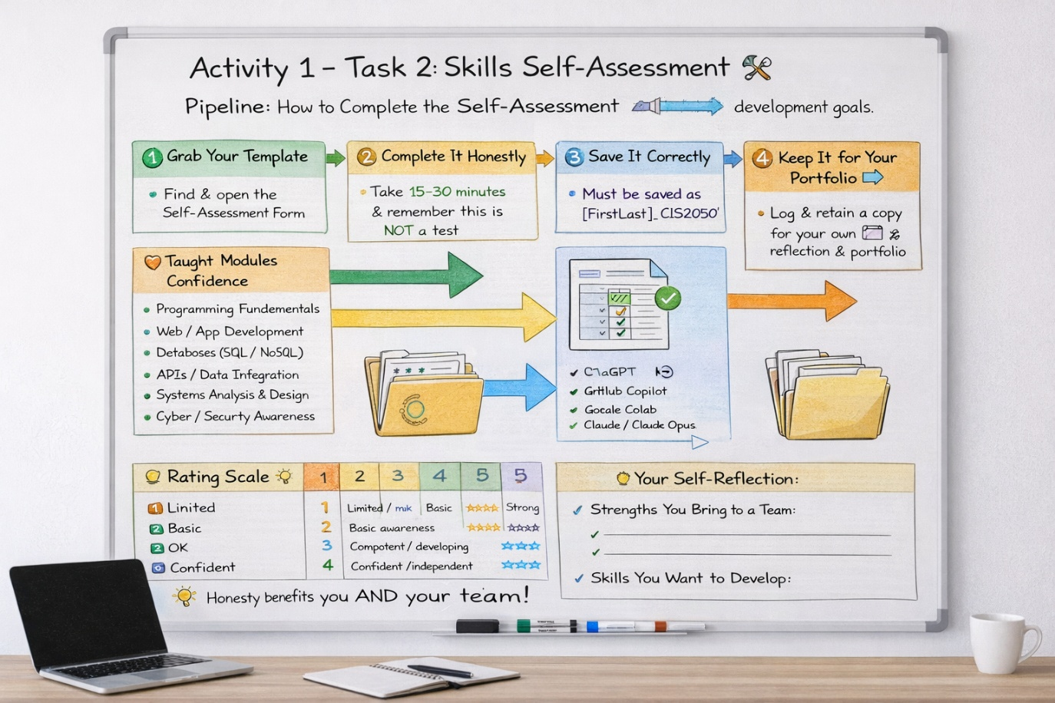

📌 Special Instructions (Read Carefully)
You will later be asked to convert this audit into:
- 🎥 a 2-minute highlight vBlog: “My Junior Developer Skills”
OR
- 📊 a 1–2 slide PowerPoint summary
For now:
✔ Complete this form honestly
✔ Focus on what you can actually design, build, or support today
✔ This is a baseline audit, not a judgement
You are encouraged to review the 2025 version and personalise language to reflect your own professional skillset.

🎯 Purpose of Task 2
This activity supports early professional self-reflection and enables you to:
- Audit your Systems Design (SD) skills separately from coding
- Audit your coding capability and developer tech stack realistically
- Identify strengths you bring to a Junior Developer team
- Identify skills to develop during the Enterprise Project
- Support fair team formation and role allocation
- Establish a baseline record for reflection, peer assessment, and employability
📌 This is not a test
📌 There are no right or wrong answers
📌 Honesty benefits you, your team, and fair marking

🔍 How This Task Is Used
Your completed self-assessment will be used to:
- Support draft team role discussions
- Help tutors balance teams fairly
- Inform peer-assessment moderation
- Feed into your individual reflection
- Evidence industry-aligned professional awareness

📝 Instructions
- Complete all sections individually
- Use the rating scales honestly
- Add short comments where helpful
- Save using the required naming format
- Keep a copy for your Employability Portfolio
⏱️ Recommended time: 15–30 minutes

👩‍💻 Junior Developer Skills Self-Assessment – v2026

Student & Module Details
Field | Your Entry
Student Name | Declan Moore
Student Email | C2201962@live.tees.ac.uk
Date | 20/01/26
Course / Pathway | CS / SE / AI / IT / Cyber / Forensics
Module | CIS2050-N Enterprise Project
Team Name | TECHFUSION
Tutor | Paolo Modesti
Lab Slot | 12:00-14:00

Section A – Core Computing Confidence (Taught Areas)
Rate your confidence based on prior learning and experience.
Area | 1 | 2 | 3 | 4 | 5
Programming Fundamentals | ☐ | ☐ | ☐ | ☐ | ☐
Web / App Development | ☐ | ☐ | ☐ | ☐ | ☐
Databases & Data Handling | ☐ | ☐ | ☐ | ☐ | ☐
Systems Analysis & Design | ☐ | ☐ | ☐ | ☐ | ☐
Cyber / Security Awareness | ☐ | ☐ | ☐ | ☐ | ☐

Section B – Implementation Capability (General)
(High-level practical ability, separate from the detailed tech-stack audit below.)
Capability | 1 | 2 | 3 | 4 | 5
I can implement features from requirements / user stories | ☐ | ☐ | ☐ | ☐ | ☐
I can read and understand existing code and contribute fixes | ☐ | ☐ | ☐ | ☐ | ☐
I can work with databases (queries / CRUD / schema changes) | ☐ | ☐ | ☐ | ☐ | ☐
I can integrate or consume APIs (basic request/response) | ☐ | ☐ | ☐ | ☐ | ☐
I can test/debug and explain how I fixed an issue | ☐ | ☐ | ☐ | ☐ | ☐
I can document my work (comments, README, short guides) | ☐ | ☐ | ☐ | ☐ | ☐
📌
You are not expected to be a full-stack expert.

🔧 Section B1 – Programming Languages Audit (Required)
Tick all that apply, then rate your practical level.
Language | Never Used | Basic | Intermediate | Confident | Evidence (optional)
Python | ☐ | ☐ | ☐ | ☐
Java | ☐ | ☐ | ☐ | ☐
C# / .NET | ☐ | ☐ | ☐ | ☐
JavaScript | ☐ | ☐ | ☐ | ☐
TypeScript | ☐ | ☐ | ☐ | ☐
PHP | ☐ | ☐ | ☐ | ☐
C / C++ | ☐ | ☐ | ☐ | ☐
R | ☐ | ☐ | ☐ | ☐
SQL (general) | ☐ | ☐ | ☐ | ☐
Other (specify): ______ | ☐ | ☐ | ☐ | ☐
📌 “Confident” = you could implement features or debug with limited support.

🧱 Section B2 – Frameworks & Development Stacks
Frontend / UI
Tool | Used | Confidence (1–5)
HTML / CSS | ☐ | 3
React | ☐
Angular | ☐
Vue | ☐
Bootstrap / Tailwind | ☐
Figma (UI only) | ☐

Backend / Application Frameworks
Framework | Used | Confidence (1–5)
Flask | ☐
Django | ☐
ASP.NET / .NET Core | ☐
Node.js / Express | ☐
Spring Boot | ☐
PHP (Laravel / plain) | ☐

Mobile / Low-Code
Platform | Used | Confidence (1–5)
Android (Java/Kotlin) | ☐
Flutter | ☐
React Native | ☐
Power Apps | ☐

🗄️ Section B3 – Databases & Data Technologies
Relational
Database | Used | Confidence (1–5)
MySQL | ☐ | 2
SQL Server | ☐ | 2
PostgreSQL | ☐
SQLite | ☐

NoSQL / Cloud
Database | Used | Confidence (1–5)
MongoDB | ☐
Firebase / Firestore | ☐
Azure Cosmos DB | ☐

☁️ Section B4 – Platforms, Cloud & Deployment
Technology | Used | Confidence (1–5)
GitHub | ☐
GitHub Actions / CI | ☐
Docker | ☐
Azure | ☐
AWS | ☐
Localhost only (no deploy yet) | ☐

🛠️ Section B5 – Developer Tools & Practices
Tool / Practice | Used | Confidence (1–5)
Git (branching, commits) | ☐
REST APIs (consume or build) | ☐
Unit Testing | ☐
Debugging tools | ☐
Logging / error handling | ☐
Agile tools (Jira / Trello / Planner) | ☐

Section C – Systems Design (SD) & Modelling Audit ⭐ Key Section
This section audits your design thinking, not coding.
Design Capability | 1 | 2 | 3 | 4 | 5
Requirements Identification | ☐ | ☐ | ☐ | ☐ | ☐
User Stories & MoSCoW | ☐ | ☐ | ☐ | ☐ | ☐
Wireframes / Page Layouts | ☐ | ☐ | ☐ | ☐ | ☐
UML (Use Case, Class, Sequence) | ☐ | ☐ | ☐ | ☐ | ☐
ER Diagrams / Data Models | ☐ | ☐ | ☐ | ☐ | ☐

📌 You can be strong in EP even if you are not a strong coder.

Section D – Professional & Team Skills
Skill | 1 | 2 | 3 | 4 | 5
Teamwork & Collaboration | ☐ | ☐ | ☐ | ☐ | ☐
Communication | ☐ | ☐ | ☐ | ☐ | ☐
Time Management | ☐ | ☐ | ☐ | ☐ | ☐
Adaptability & Learning | ☐ | ☐ | ☐ | ☐ | ☐
Taking Initiative | ☐ | ☐ | ☐ | ☐ | ☐

Section E – Work Experience & Employability
Area | 1 | 2 | 3 | 4 | 5
Tech / Digital Industry Experience | ☐ | ☐ | ☐ | ☐ | ☐
Non-Tech Work Experience | ☐ | ☐ | ☐ | ☐ | ☐
Customer / Client Interaction | ☐ | ☐ | ☐ | ☐ | ☐
Professional Conduct | ☐ | ☐ | ☐ | ☐ | ☐

🆕 Section F – AI Tools & Responsible Usage (Audit-Ready)
AI-Supported Activity | Used Before? | Confidence (1–5)
Idea generation / brainstorming | ☐ Yes ☐ No | 4
Code explanation / debugging | ☐ Yes ☐ No | 3
Writing support | ☐ Yes ☐ No | 3
Research summarisation | ☐ Yes ☐ No
Visuals / diagrams / posters | ☐ Yes ☐ No | 2

AI Tools Used (tick all):
☐ ChatGPT ☐ GitHub Copilot ☐ Google Colab ☐ Claude ☐ Adobe Express
☐ Other: ____________________
📌 All AI usage must be referenced and auditable.

Section G – Preferred & Developing Technologies
Technologies I am confident working with:
•
Technologies I want to learn during this project:
•
Technologies I prefer NOT to be lead developer on (for now):
•

Section H – Evidence Awareness (Lightweight Audit)
Tick any evidence you could realistically provide if requested:
☐ GitHub repository
☐ Screenshots of working code
☐ Coursework submission
☐ Demo video (30–180 seconds)
☐ Group project contribution
☐ None yet (learning phase)

Section I – Skills You Bring to a Team
List 2–3 strengths you can genuinely contribute.
• Adaptability
• Communication
•

Section J – Skills You Want to Develop
• Programming
• Networking
• Researching

✅ Declaration
I confirm that this self-assessment is an honest reflection of my current skills and experience.
Student Name: Declan Moore
Date: 20/01/26

📊 Rating Scale (1–5)
Score | Meaning
1 | Very limited / no experience
2 | Basic awareness
3 | Competent / developing
4 | Confident / independent
5 | Advanced / can support others

🔄 What Happens Next
• Teams discuss draft roles
• Tutors review balance & fairness
• Skills revisited during peer assessment
• SD and coding claims to eventually be supported by evidence in your EP Portfolio
• AI usage logged under DevWorks audit practice

Self-Study:
Generate an intro slide or 2, a Bio Poster, a Blog, vLog or a mini video (2mins) about YOU!.
